1. (25p) Answer all the questions on an electronic document. By taking the MATLAB routines developed along session 1:
2. Depict the spectrum corresponding to a 1 μm single pulse modulated to operate at a carrier frequency of 5 MHz and with 1MJ of energy.

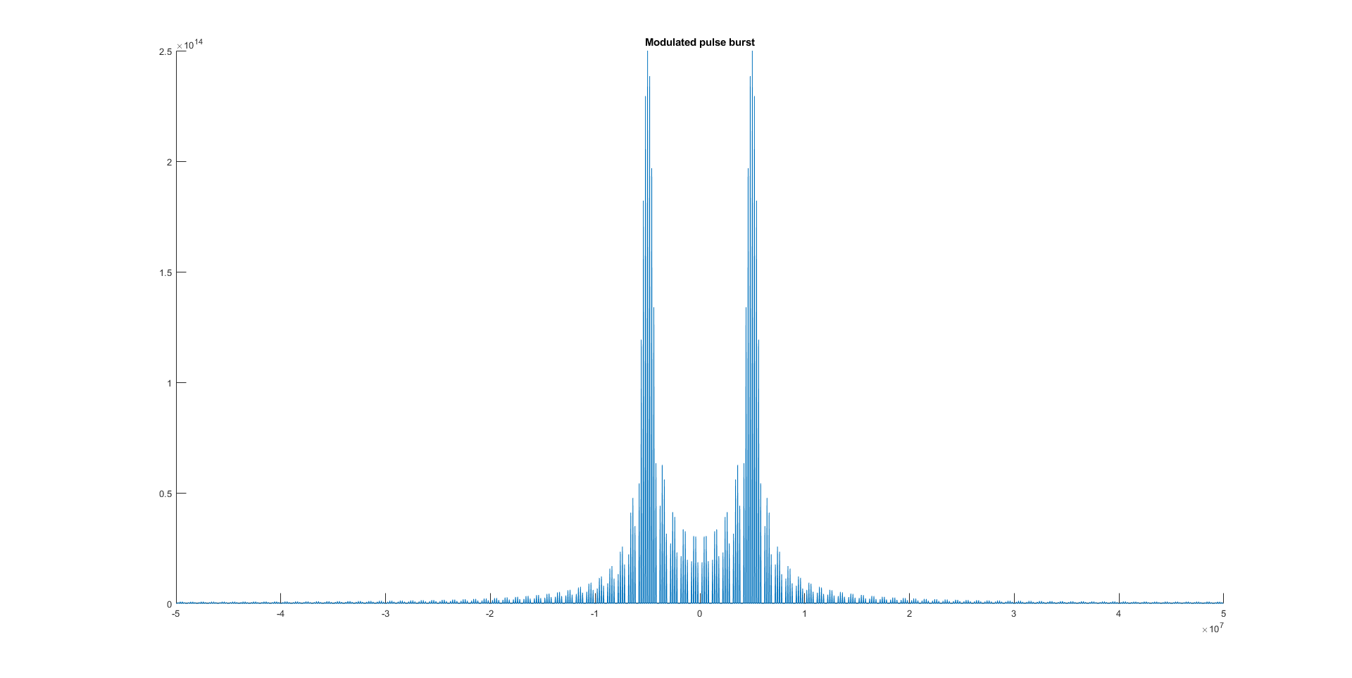

1. In the same figure depict the spectrum of a twice long pulse with equal energy. 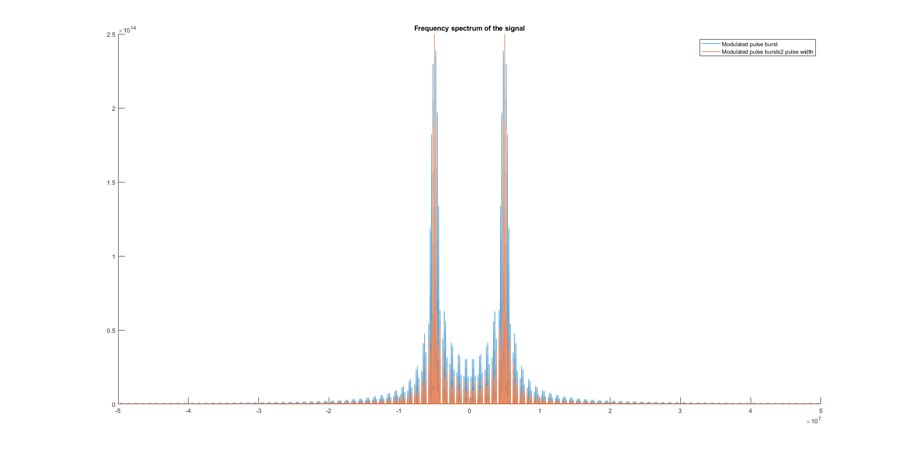
2. Comment on the difference between the two spectrums.

As the peak power changes, due to the fact that the energy of the signal remains same. The main difference is the fact that the signal now has the spectrum energy per area less spread out compared to the original pulse width. Thus, the signal is much narrower. Thus increasing the